Belgische Vereniging voor Weefsel- en Celbanken V.Z.W.
Association belge de Banques de Tissues et Cellules A.S.B.L.
www.bvwb-abbt.be
info@bvwb-abbt.be
Maatschappelijke Zetel/Siège Social
Universitair Ziekenhuis Antwerpen
Wilrijkstraat 10 – B2650 EDEGEM
Ondernemingsnummer/Numéro de société
818.374.449

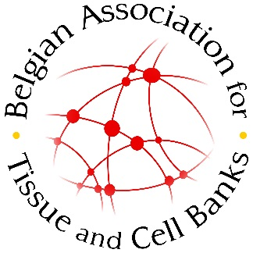

SPONSORSHIP 2017
Company:
Name of executive:
Address:
Tel.: Fax:
Email:
VAT number:

By signing this document, we confirm to support the BELGIAN ASSOCIATION FOR TISSUE AND CELL BANKS (BVWB-ABBT) by means of the following contribution. The document should be sent to info@bvwb-abbt.be.

Signature:

Gold sponsor: 2000 Euro/year
- Company logo on the BVWB-ABBT home page with hyperlink to own company website
- Company logo on all printed invitations of symposia organized by the BVWB-AABT
- Company logo on promotion slide of the Spring symposium 2017
- Availability of the membership names and institutes on request
- Availability of the names and institutes of participants to the scientific meeting on request
- Stand at the Spring symposium 2017 (6m³, 3x2m)
- Insert in the congress map at the Spring symposium 2017
- Joint membership for 2017
Belgische Vereniging voor Weefsel- en Celbanken V.Z.W.
Association belge de Banques de Tissues et Cellules A.S.B.L.
www.bvwb-abbt.be
info@bvwb-abbt.be
Maatschappelijke Zetel/Siège Social
Universitair Ziekenhuis Antwerpen
Wilrijkstraat 10 – B2650 EDEGEM
Ondernemingsnummer/Numéro de société
818.374.449

Silver sponsor: 1000 Euro/year
- Company logo on all printed invitations of the Spring Symposium 2017
- Company logo on promotion slide of the Spring symposium 2017
- Availability of the names and institutes of participants to the scientific meeting on request
- Stand at the Spring symposium 2017 (6m³, 3x2m)
- Insert in the congress map at the Spring symposium 2017
- Joint membership for 2017

Bronze sponsor: 750 Euro/year
- Company logo on promotion slide of the Spring symposium 2017
- Stand at the Spring symposium 2017 (6m³, 3x2m)
- Insert in the congress map at the Spring symposium 2017
- Joint membership for 2017

